14 ⁶ Then I saw another angel flying directly overhead, with an eternal gospel to proclaim to those who dwell on earth, to every nation and tribe and language and people. ⁷ And he said with a loud voice, “Fear God and give him glory, because the hour of his judgment has come, and worship him who made heaven and earth, the sea and the springs of water.” ⁸ Another angel, a second, followed, saying, “Fallen, fallen is Babylon the great, she who made all nations drink the wine of the passion of her sexual immorality.” ⁹ And another angel, a third, followed them, saying with a loud voice, “If anyone worships the beast and its image and receives a mark on his forehead or on his hand, ¹⁰ he also will drink the wine of God's wrath, poured full strength into the cup of his anger, and he will be tormented with fire and sulfur in the presence of the holy angels and in the presence of the Lamb. ¹¹ And the smoke of their torment goes up forever and ever, and they have no rest, day or night, these worshipers of the beast and its image, and whoever receives the mark of its name.”
¹² Here is a call for the endurance of the saints, those who keep the commandments of God and their faith in Jesus.
¹³ And I heard a voice from heaven saying, “Write this: Blessed are the dead who die in the Lord from now on.” “Blessed indeed,” says the Spirit, “that they may rest from their labors, for their deeds follow them!” ¹⁴ Then I looked, and behold, a white cloud, and seated on the cloud one like a son of man, with a golden crown on his head, and a sharp sickle in his hand. ¹⁵ And another angel came out of the temple, calling with a loud voice to him who sat on the cloud, “Put in your sickle, and reap, for the hour to reap has come, for the harvest of the earth is fully ripe.” ¹⁶ So he who sat on the cloud swung his sickle across the earth, and the earth was reaped. ¹⁷ Then another angel came out of the temple in heaven, and he too had a sharp sickle.¹⁸ And another angel came out from the altar, the angel who has authority over the fire, and he called with a loud voice to the one who had the sharp sickle, “Put in your sickle and gather the clusters from the vine of the earth, for its grapes are ripe.” ¹⁹ So the angel swung his sickle across the earth and gathered the grape harvest of the earth and threw it into the great winepress of the wrath of God. ²⁰ And the winepress was trodden outside the city, and blood flowed from the winepress, as high as a horse's bridle, for 1,600 stadia.
15 Then I saw another sign in heaven, great and amazing, seven angels with seven plagues, which are the last, for with them the wrath of God is finished.
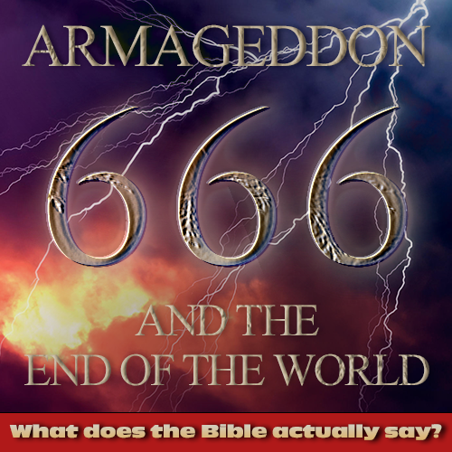
² And I saw what appeared to be a sea of glass mingled with fire—and also those who had conquered the beast and its image and the number of its name, standing beside the sea of glass with harps of God in their hands. ³ And they sing the song of Moses, the servant of God, and the song of the Lamb, saying,
“Great and amazing are your deeds,
O Lord God the Almighty!
Just and true are your ways,
O King of the nations!
⁴ Who will not fear, O Lord,
and glorify your name?
For you alone are holy.
All nations will come
and worship you,
for your righteous acts have been revealed.”

Is it time to leave the doctrine of God’s judgment behind?

1) The announcement of judgment is great news (14:6-12)

2) Jesus has been appointed to gather and judge (14:13-20)

3) And trusting this will lead the nations to worship (15:1-4)

Coffee Questions

- Do you think of Jesus’ judgment as great news, why or why not?
What practical difference does it make to you knowing that Jesus will judge the world?

- How does this passage give you confidence to stand for Jesus even when it’s costly?

